Assistance League® of St. Louis Assistance League Outreach Program
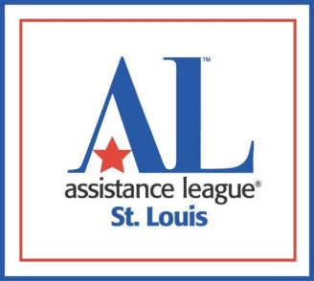

Request for Assistance

From a social service agency, school district or nonprofit organization

Assistance League Outreach fills vetted requests from agencies and schools for emergency assistance, one-time per family, to meet specific community needs.

GUIDELINES: The Request for Assistance is for goods which are to be delivered directly to the end user via the social service agency, school, vendor or nonprofit organization. Items delivered cannot be sold.

Agency/School Name
Agency/School Address
Telephone Number
Name & Title of contact completing form
Contact Email address
Ages & genders of individuals receiving goods

Describe the situation and what specific assistance and goods would benefit this client.

Describe why you think this client is a good candidate for this request

Items not provided through Assistance League Outreach Program | Request for financial obligations such as bill payments, payments for utilities, rent or requests for cash will not be considered. Additionally, car repairs, medical bills, food and celebration events will not be considered.

Send this request to: Outreach@stlouisassistanceleague.org

Outreach Date Received __________ Date Approved ___________ Date Delivered ___________

Revised 1/23

