Assistance League® of St. Louis Assistance League Outreach Program

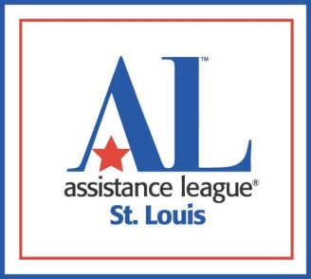

Request for Assistance

From a social service agency, school district or nonprofit organization

Assistance League Outreach fills vetted requests from agencies and schools for emergency assistance, one-time annually per family, to meet specific community needs.

GUIDELINES: The Request for Assistance is for goods or services which are to be delivered directly to the end user via the social service agency, school, vendor or nonprofit organization.

Agency/School Name
Agency/School Address
Telephone Number
Name & Title of contact completing form
Email address
Ages & genders of individuals receiving goods

Briefly describe the situation and list the requested items.
Describe why you think this client is a good candidate for this request and how this assistance would impact their life.

Items not provided through Assistance League Outreach Program | Request for financial obligations such as bill payments will not be considered.  Financial obligations would include bill payments, utilities and rent or requests  for cash. Additionally, car repairs, medical bills, food and celebration events will  not be considered.

Send this request to: Outreach@alstl.org

Revised 2/2022

